ARYAMAN MISHRA

19BCE1027

1) DATA SEGMENT

org 1000h

array db 11h, 22h, 33h, 44h, 55h, 66h, 77h, 88h, 99h, 10h

org 2000h

evn db ?

org 3000h

odd db ?

data ends

CODE SEGMENT

assume cs:code, ds:data

start: mov ax,data

mov ds, ax

lea si, array

lea di, odd

mov ax, 00h

mov cl, 0ah

up: mov al, [si]

mov bl, 02

div bl

cmp ah, 00h

je l1

mov al, [si]

mov [di], al

inc di

l1: inc si

dec cl

jnz up

lea si, array

lea di, evn

mov cl, 0ah

up1: mov al, [si]

mov bl, 02h

div bl

cmp ah, 00h

jne l2

mov al, [si]

mov [di], al

inc di

l2: inc si

dec cl

jnz up1

skip: mov ah, 4ch

int 21h

code ends

end start

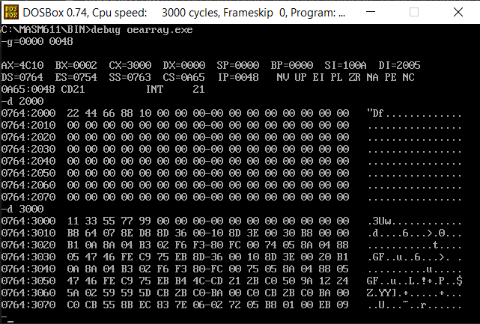

2) ASSUME CS:CODE

CODE SEGMENT

START:MOV SI,5000H

MOV AX,[SI]

AND AX,000FH

MOV CL,4

MOV BX,[SI]

SHR BL,CL

MOV AH,BL

MOV BX,3030H

OR AX,BX

INT 3

CODE ENDS

END START

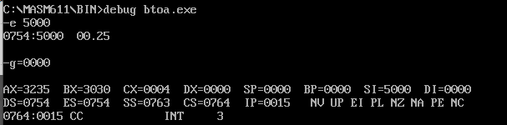

3) ASSUME CS:CODE

CODE SEGMENT

START:MOV SI,500

MOV DI,600

MOV BL,[SI]

AND BL,000FH

MOV AL,[SI]

AND AL,00F0H

MOV CL,04

ROR AL,CL

MOV DL,000AH

MUL DL

ADD AL,BL

MOV [DI],AL

HLT

CODE ENDS

END START

